Alexandria University,

Faculty of Engineering,

Computer and Systems Engineering Dept.

Numerical Analysis

CS213

*Final Project*

Roots Of Equations

Part1

Names:

1. Ziad Hisham Ali. (19)
2. Mohamed Salah Mahmoud (41)
3. Mohamed Mohamed Abdel-Hakeem (43)
4. Youssef Ahmed Sayed Gabriel. (61)
5. Problem Statement:

Find Roots of equations with multiple methods.

1. Pseudo Code:

* **Bisection Method:**

Parameters : ( Equation, two initial guesses Lower&Upper , max number

of iterations, Epsilon )

Algorithm : make an iteration of size n, in each iteration get Xr that

was (L+U)/2, get product between value of equation at L &

Xr, “if less than Zero, then U = Xr “ Else “if greater than

Zero, hen L = Xr” Else “L & U = Xr”

And if L = 0 , increment it with low value 0.000001

Finally, calculate the error (U-L)/L ,If less than the Epsilon

, break from the loop and Xr is the root of the equation

In each iteration “iterate, Xr, error, L, U” stored in array

Also calculate number of expected iterations

Plot : 1.Draw plot between number of iterations & root using the array

2.Draw plot between number of iterations & error using the

Array

3. Draw plot between x & f(x) using the array

* **False Position Method:**

Parameters : ( Equation, two initial guesses Lower&Upper , max number

of iterations, Epsilon )

Algorithm : Initiate Xr = 0 ,make an iteration of size n, in each

iteration set XrOld = Xr & Xr = U – [F(U)*(L-U)/F(L)-F(U)]

get the value of equation at Xr, then get product between

F(Xr)&F(L) and if greater than 1 “L = Xr & F(L) = F(Xr)”

Else if less than 1 “U = Xr & F(U) = F(Xr)” Else “error = 0”

If iterate counter > 1 , then calculate the error

that equal (Xr-XrOld)/Xr and calculate precision that

equal (100 – error) and if Error < Epsilon , then

break from the loop and Xr is the Root Else.

In each iteration “iterate, Xr, error, L, U” stored in array

Plot : 1.Draw plot between number of iterations & root using the array

2.Draw plot between number of iterations & error using the

Array

3. Draw plot between x & f(x) using the array

* **Fixed Point Iteration Method:**

Parameters : ( Equation, One initial guess X0 , max number

of iterations, Epsilon )

Algorithm : Initiate Xr = 0 ,make an iteration of size n, in each

iteration set Xr = F(X0) And if Xr = 0 , increment it with

low value 0.000001 , then calculate the Error that equal

(Xr-X0)/Xr and calculate precision that

equal (1 – error)*100 and if Error < Epsilon , then

break from the loop and Xr is the Root ,Else X0 = Xr.

In each iteration “iterate, Xr, error, X0” stored in array

Also calculate rate of convergence in each iteration

Plot : 1.Draw plot between number of iterations & root using the array

2.Draw plot between number of iterations & error using the

Array

3. Draw plot between x & f(x) using the array

* **Newton_Raphason Method:**

Parameters : ( Equation, One initial guess X0 , max number

of iterations, Epsilon )

Algorithm : Initiate Xr = 0 And get 1st derivative of the equation &

2nd derivative of the equation,

Make an iteration of size n, in each

iteration set Xr = X0 – [F(X0)/dF(X0)] And if dF(X0)= 0 ,

increment X0 with low value 0.000001 then calculate the

Error that equal (Xr-X0)/Xr and calculate precision that

equal (1 – error)*100 and if Error < Epsilon , then

break from the loop and Xr is the Root ,Else X0 = Xr.

In each iteration “iterate, Xr, error, X0” stored in array

Also calculate theoretical error

Plot : 1.Draw plot between number of iterations & root using the array

2.Draw plot between number of iterations & error using the

Array

3. Draw plot between x & f(x) using the array

* **Secant Method:**

Parameters : ( Equation, Two initial guess X0&X1 , max number

of iterations, Epsilon )

Algorithm : Initiate Xr = 0, Make an iteration of size n, in each

iteration set Xr = X1 – [F(X1)*(X1-X0)/F(X1)-F(X0)] ,

then calculate the Error that equal (Xr-X1)/Xr and

calculate precision that equal (1 – error)*100 and if Error <

Epsilon , then break from the loop and Xr is the Root ,Else

X0 = X1 & X1 = Xr.

In each iteration “iterate, Xr, error, X0, X1” stored in array

Plot : 1.Draw plot between number of iterations & root using the array

2.Draw plot between number of iterations & error using the

Array

3. Draw plot between x & f(x) using the array

* **Bierge Vieta Method:**

Parameters : ( Equation, One initial guess X0 , max number

of iterations, Epsilon )

Algorithm : First make 2D-Array of length degree of the equation+1

And width 4 ,Make iteration of size “degree of the

equation+1” In each iteration call another function

**biergeVietaOneRoot** that iterate to size n , then if

iterate = 1 setb equal coff. Of x & c equal coff. Of x

Else set b = coff. Of x + (X0*b of previous iterate) &

Set c = b + (X0*c of previous iterate) , Finally calculate

Xr that equal x0-(b/c of previous iterate) & calculate the

error that equal (Xr-X0)/Xr and set X0 = Xr and if error <

Epsilon ,break from the loop and the root is Xr.

In each iteration “iterate, Xr, error, X0, X1” stored in array

Plot : 1.Draw plot between number of iterations & root using the array

2.Draw plot between number of iterations & error using the

Array

3. Draw plot between x & f(x) using the array

* **Steffensen Method “General Method”:**

Parameters : ( Equation, max number of iterations, Epsilon )

Algorithm : First, get a guess using **get_guess method** that

initiate Two variables a=-1 & b=1 and make two iterations

inside each other from 1 to 100 , set variable

r = (b-a)*Random number + a

and set variable g = r*1st iterateIndex*2nd iterateIndex /

1st iterateIndex+2nd iterateIndex , then get the value of

the function at this point g if close to zero , return it as a

guess p0.

Make an iteration of size n, in each iterate set p1 = f(p0) &

p2= f(p1) ,then calculate P = p0-(p1-p0)^2/(p2-2*p1+p0) And

calculate the error = (P-p0)/P & precision = 100-error , If

the error < Epsilon , break from the loop and the root is Xr.

Else p0 = P.

In each iteration “iterate, Xr, error, X0, X1” stored in array

Plot : 1.Draw plot between number of iterations & root using the array

2.Draw plot between number of iterations & error using the

Array

3. Draw plot between x & f(x) using the array

1. General Method “**Steffensen Method**”:

The method doesn’t need an initial guess input ,it just choose randomly one in case the value of function at this point is close to Zero, By this initial generated guess, it’s generate two next guesses points for the fixed point “p1=f(p0) & p2=f(p1)” , Then using ***Aitken’s delta Method***

Calculate a better approximation for the root

P = p0-(p1-p0)^2/(p2-2*p1+p0) then check if P is less than the assumed Epsilon , then P is the root Else continue with the same logic but the points of the fixed point will be “p0 = P & p1=f(p0) & p2=f(p1)”

**Advantages :** The main advantage of Steffensen's method is that

has a quadratic convergence so it runs quickly

the number of correct digits in the answer doubles

with each step And also the great advantage that the

other method that has a quadratic convergence

“Newton” require compute 1st derivative of the

Equation but Steffensen's doesn’t require that

Make it better than Newton

**Disadvantages :** The price for the quick convergence is the double

function evaluation, f(p0), f(p1), f(p2) is

calculated that increase the cost of calling this

function

**DataStrucures:** 2D Array to store steps in each iteration

1. Analysis Of The Methods:

x^2 – 2 = 0

|  |  |  |  |  |
| --- | --- | --- | --- | --- |
| **Methods** | **Executed Time** | **Number Of Iterations** | **Error** | **Graph** |
| BiSection | 0.0051491 | 19 | 6.7435e^-6 |  |
| False_Position | 0.0056864 | 22 | 5.949e^-5 |  |
| Fixed Point iteration | 1.1858 | 48 | 5.6435e^-6 |  |
| Newton_Raphason | 0.026702 | 22 | 7.2583e^-7 |  |
| Secant | 0.0037505 | 7 | 2.2329e^-8 |  |
| Bierge_Vieta | 0.044752 | 3 | 0 |  |
| Steffensen “General” | 1.3279 | 5 | 0.00071341 |  |

|  |  |  |  |  |
| --- | --- | --- | --- | --- |
| **Methods** | **Executed Time** | **Number Of Iterations** | **Error** | **Graph** |
| BiSection | 0.0039789 | 17 | 7.248e^-6 |  |
| False_Position | 0.008872 | 49 | 5.268e^-6 |  |
| Fixed Point iteration | 0.019047 | 62 | 6.369^e-5 |  |
| Newton_Raphason | 0.14636 | 24 | 6.9093e^-6 |  |
| Secant | 0.011743 | 63 | 2.7028e^-9 |  |
| Bierge_Vieta | 0.044091 | 4 | 2.5691e^-9 |  |
| Steffensen “General” | 1.2365 | 57 | 0.079874 |  |

x^3 – 0.165*x^2 + 3.993*10^-4

Bisection Method : Run in a short Time and take not large number of iterations

& give accurate root

FalsePosition Method : Run in a short Time bit more than biSection and take

large number of iterations & give accurate root

FixedPoint Method : Run in a long Time a bit and take large number of

iterations & give approximated root

Newton Method : Run in a long Time and take not large number of iterations

& give accurate root

Secant Method : Run in a long Time a bit and take large number of

iterations & give approximated root

Bierge-Vieta Method : Run in a long Time and take not large number of

iterations & give accurate root

General Method : Run in a short Time and take not large number of

iterations & give accurate root

1. Problematic Functions:

* **Bisection Method:**

If function is just touching the x-axis f(x) = x^2

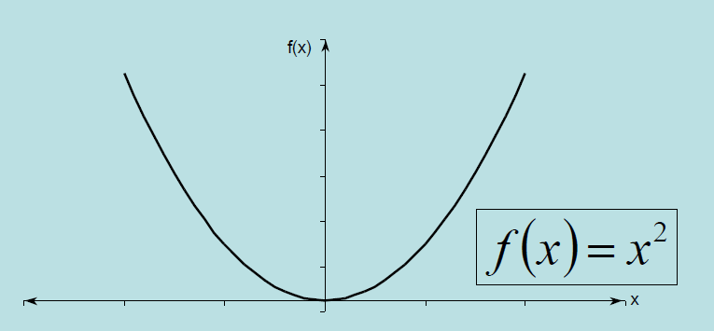

If function changes the sign but root doesn’t exist f(x) = 1/x

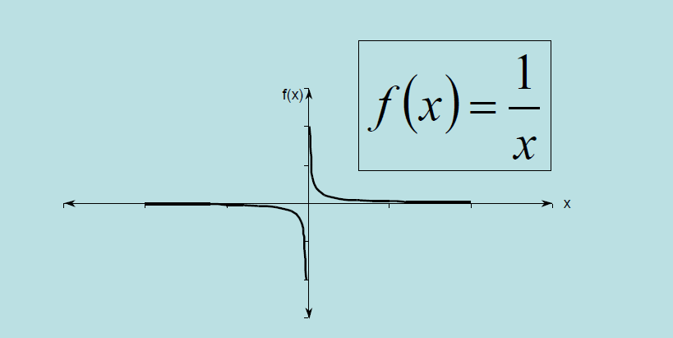

* **False Position Method:**

If initial guess away from the root

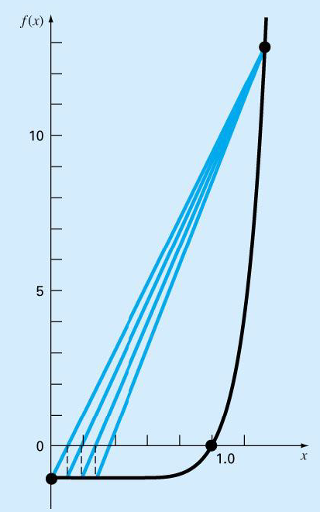

* **Fixed Point Iteration Method:**

If the function diverges, it happens when choose a bad point

that diverge and the root can’t be found

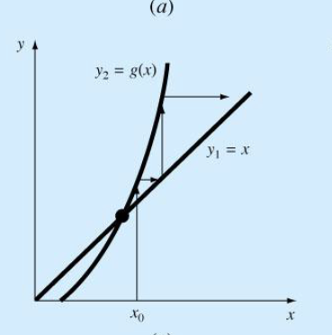

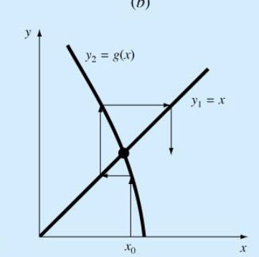

* **Newton_Raphason Method:**

Sometimes slow, f(x) = X^10 – 1

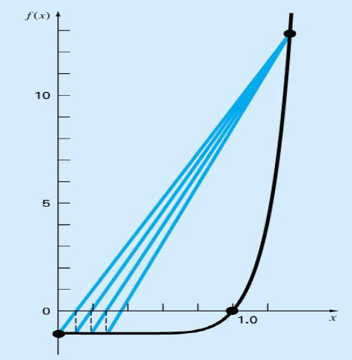

Inflection point at vicinity of root

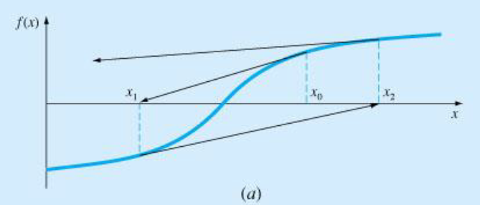

Local Max or Local Min points

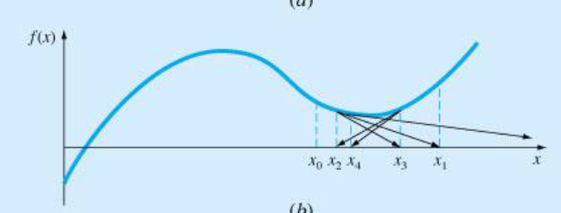

May jump from location close to root to away one

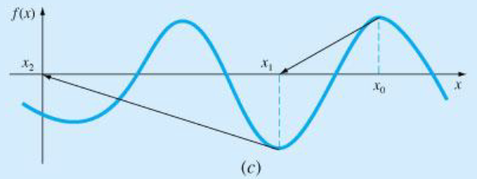

Zero Slope, cause division by zero

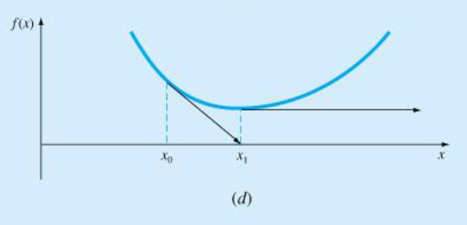

1. Sample Runs:









